

Medium Level Programs (11-20)

Date – 12/03/2026

Name: M. Sahasra
Reg. No.: 192425317
Course Code: CSA0919
Course Name: Programming in Java for Spring Framework
Faculty Name: Dr. Magesh Kumar

11. Factorial Using Recursion

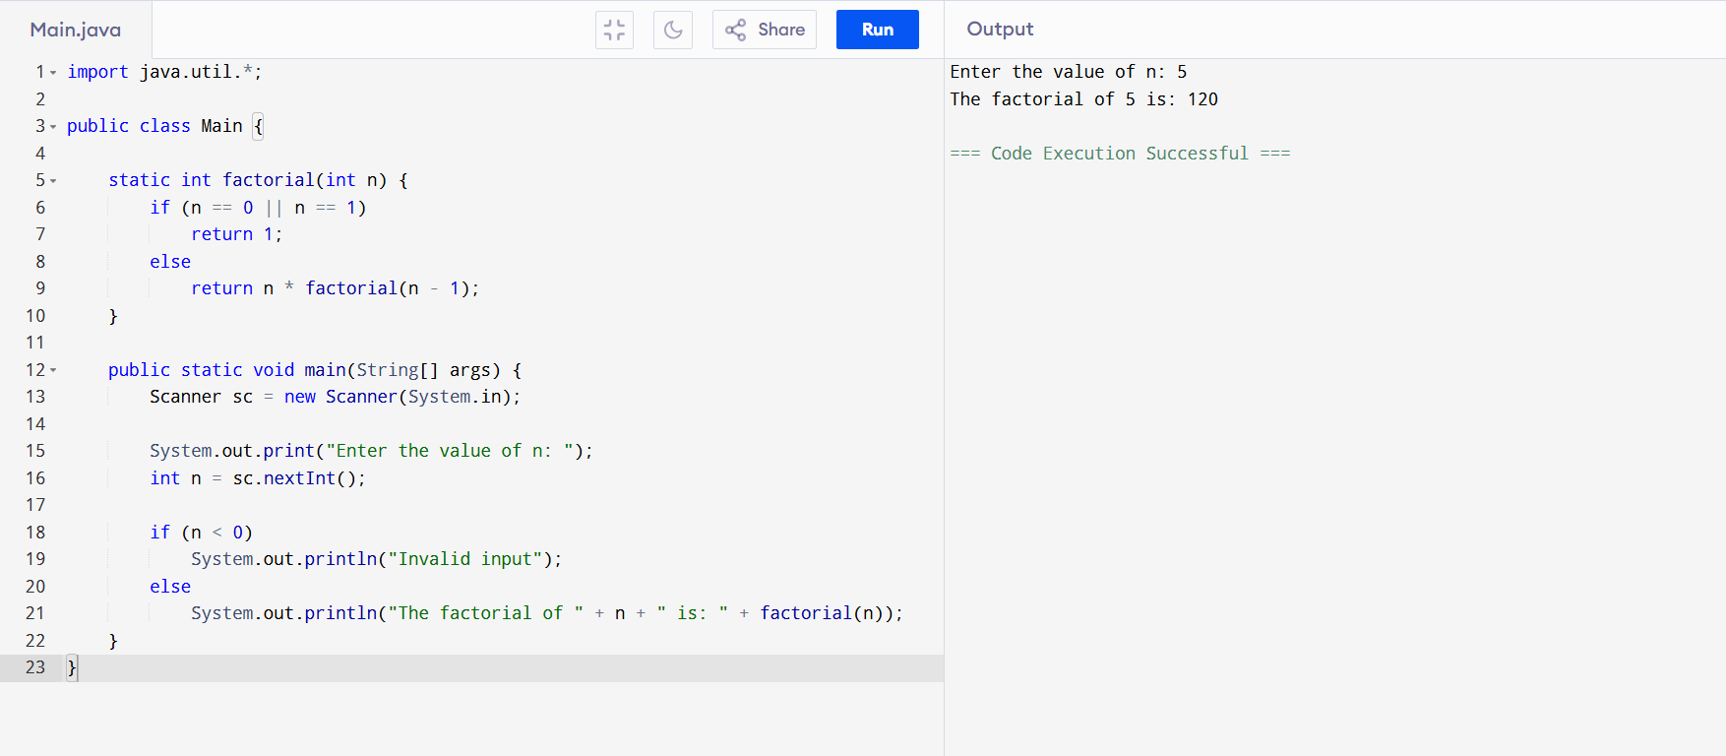

12. Nth Largest Number in Array
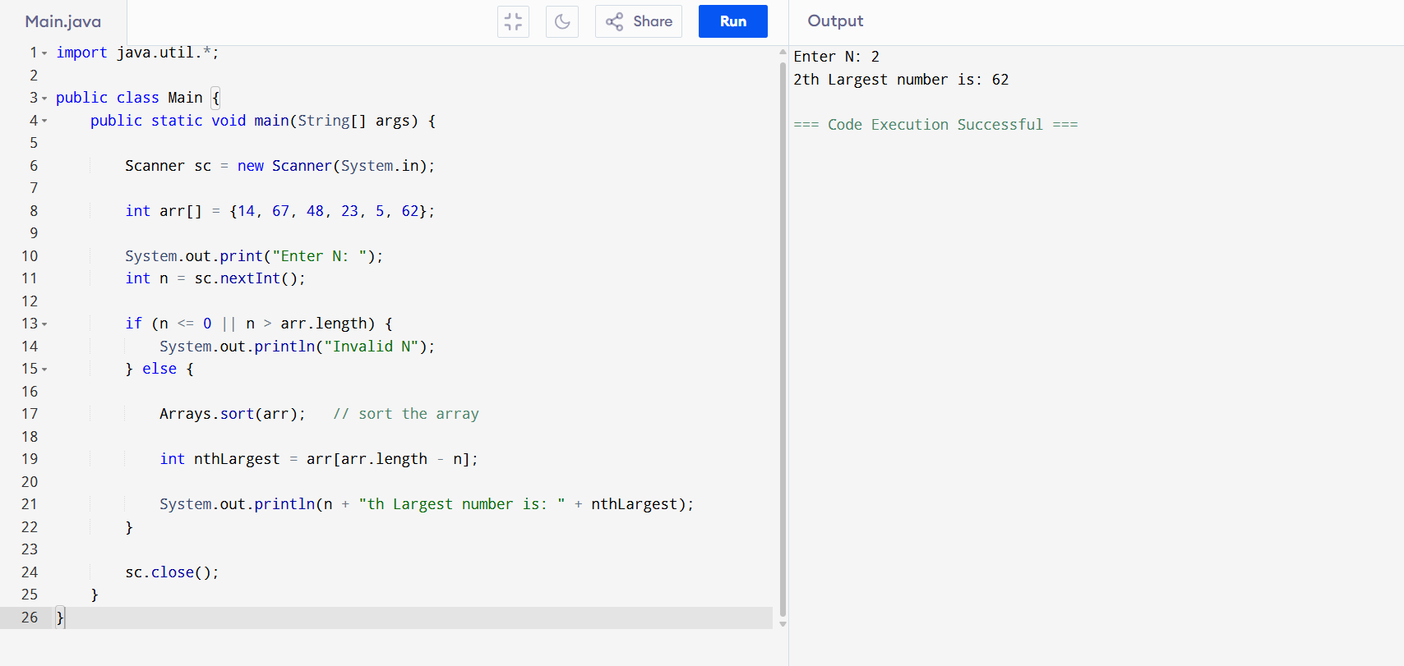
13. Binary to Decimal and Octal
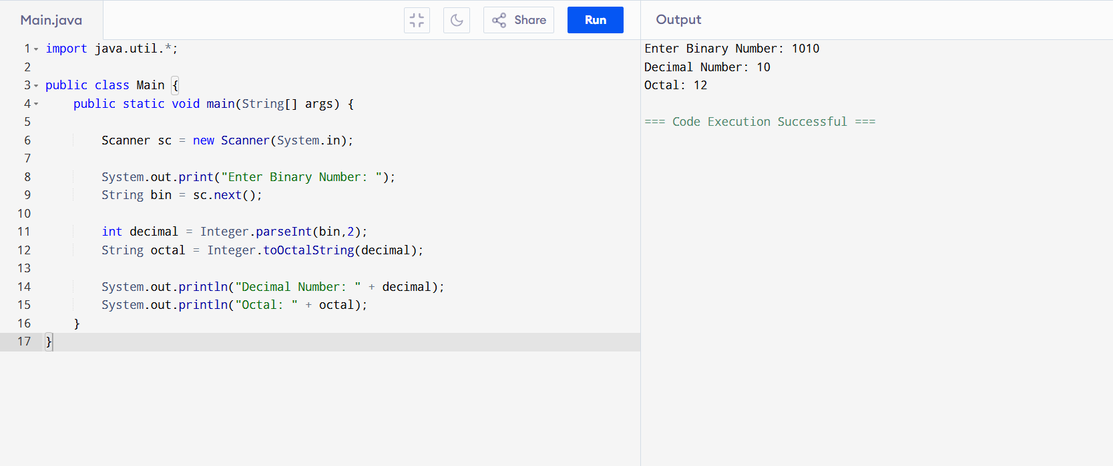
14. Count Special Characters
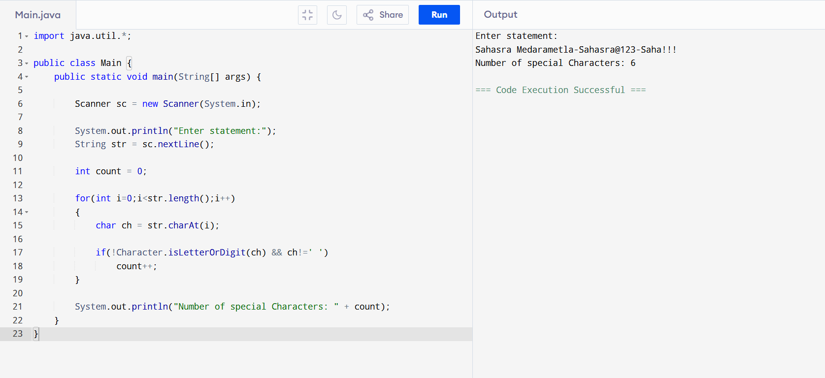
15. Remove Duplicate Elements from Array

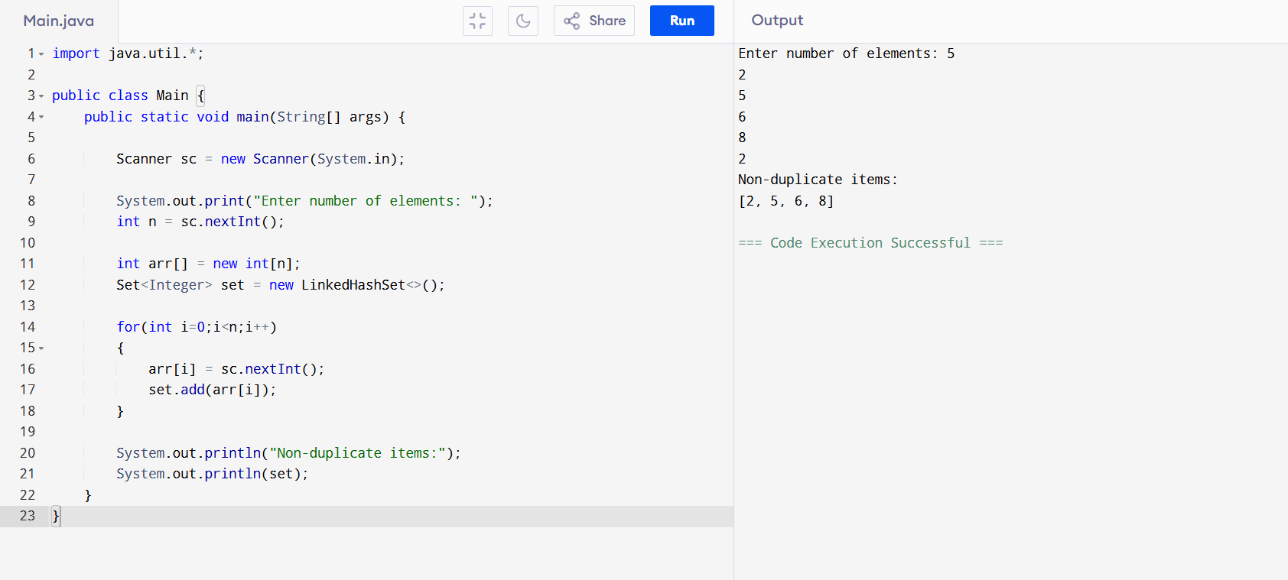

16. Bank Interest (Method Overriding)

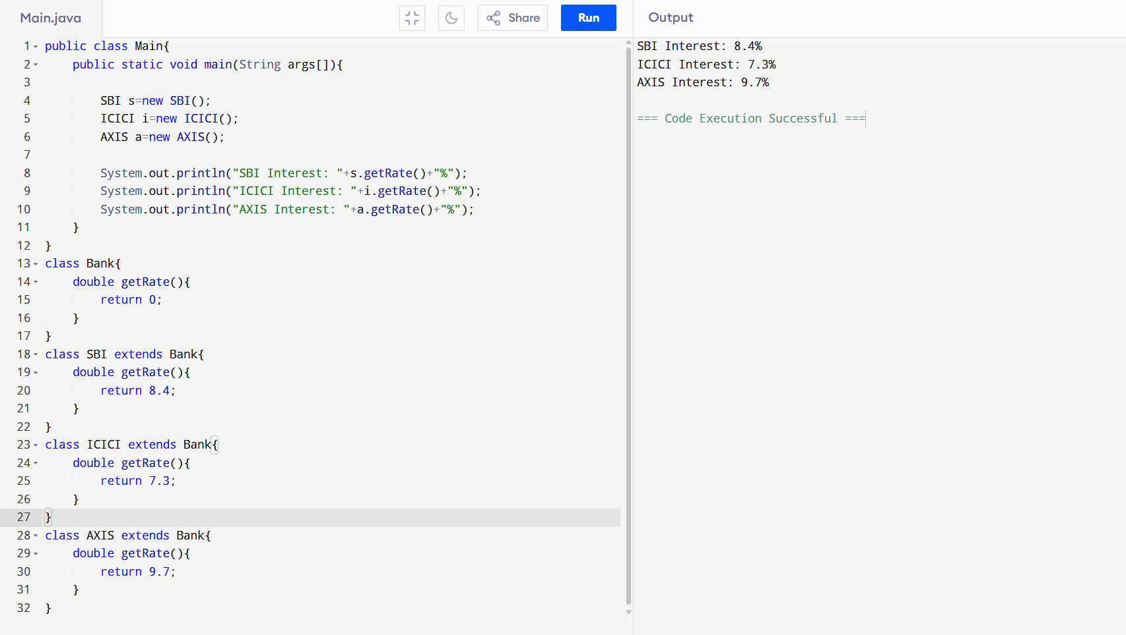

17. Super Class Constructor

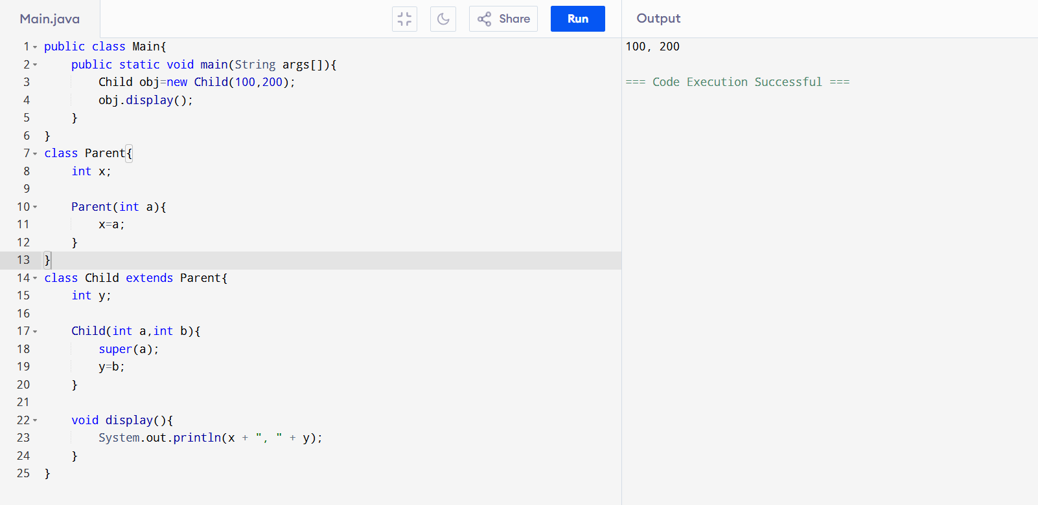

18. Multiplication Table Using Threads

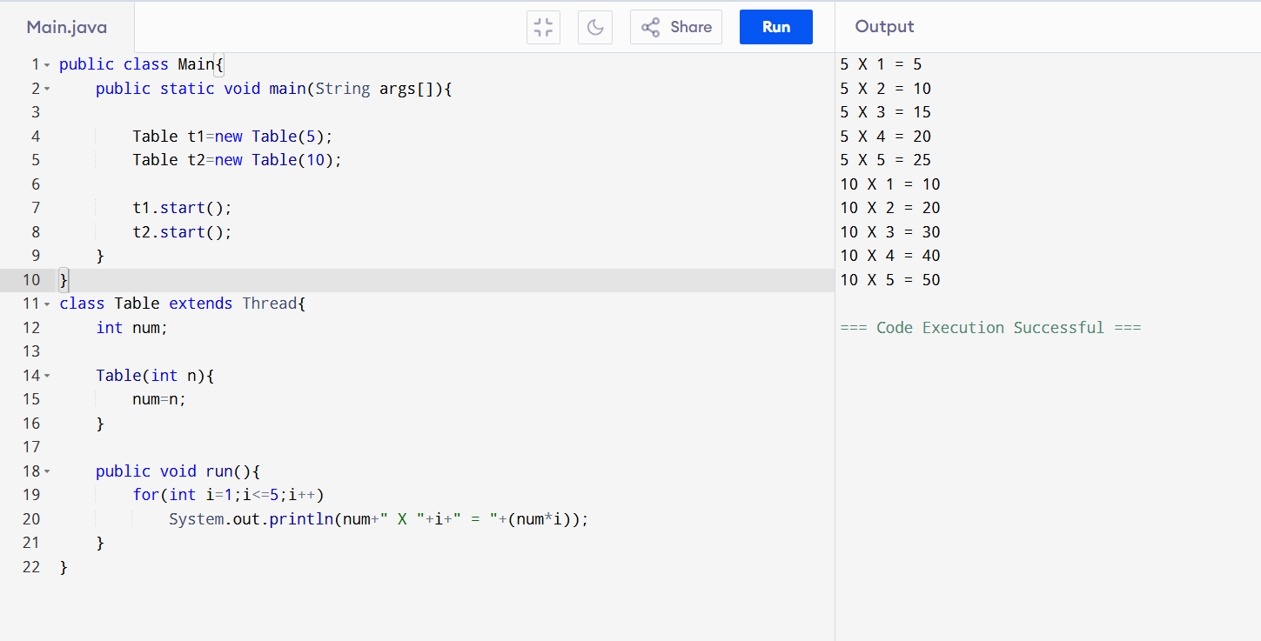

19. Fibonacci Using Runnable

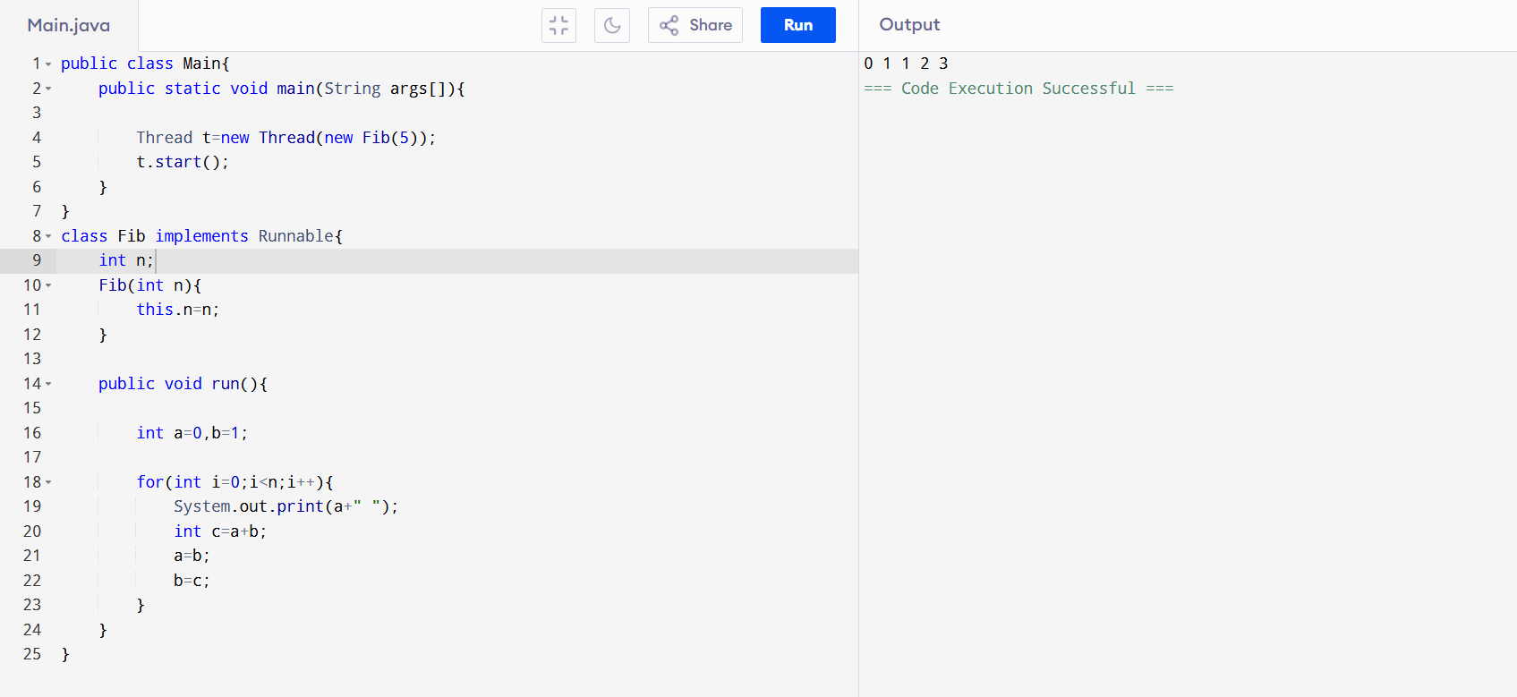

20. Sum of N Numbers with Exception
